February 1, 2018
Railroads in the 1860s

As you can see from the map at the front of Hill’s Gold, much of Nathaniel’s trip from Providence to Denver was taken by railroad. I have reproduced it below because my clever cartographer color coded the modes of transportation: railroad, steamship, and stagecoach. According to Nathaniel’s letters, the short stretch from St. Louis to Hannibal by steamship was the section he enjoyed the most.

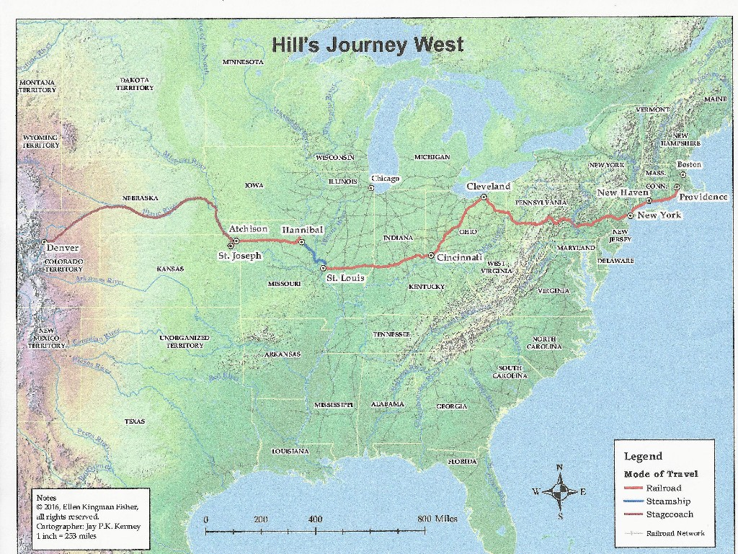

The Iron Horse, or steam locomotive, changed transportation and accelerated the development of the West. Before the 1850s and 1860s people mostly traveled by horse, stage, or even walking. In the East there were canals, but they froze in the winter. Trails were filled with rocks, potholes, and other hazards. Rain often washed away the roads altogether and crossing creeks and rivers was a frequent necessity. To add to the suffering, travelers had to endure inclement weather.

The concept of a transcontinental railroad began in the 1850s. In fact, Congress passed a series of acts promoting potential sites in 1853. All sections of the country vied to have the railroad go through their territory and no route could be agreed on. It wasn’t until the South seceded, that the 1862 Pacific Railroad Act designated construction of a railroad and telegraph line from the Missouri River to the Pacific Ocean. Construction of a transcontinental railroad began.

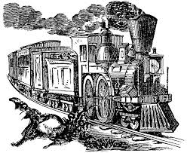

I am uncertain how many trains Nathaniel took on his trip to Colorado, but the train pictured above is probably similar to some of them. From what he described, the roadbed was rough and uneven. Tracks had been laid as fast as possible, often by amateur engineers. The bumpy ride and sharp curves often made people train sick.

The seats were made of either wooden slats or tufted leather, usually with a footrest. Some seats could recline, but Nathaniel described no sleeping accommodations. Nor were there dining cars. Stops were made to take on water for the steam locomotive and secondarily to allow passengers to get whatever food might be available.
Ventilation was always a problem. Dust and cinders sifted in through the window, coating everything with soot. Rancid smells from the hot animal fats used to lubricate the axles wafted in too. Most cars included a stove that spewed suffocating smoke in the winter.
Toilets on the train were simply holes that emptied onto the tracks. To get from one car to another, people had to leap over the uncovered mechanical coupling. At night, interior lights flickered out leaving everyone in the dark, except when the conductor stumbled through the trash-strewn aisles carrying a lantern. To add to the discomfort, trains were sometimes attacked by marauders and occasional mechanical breakdowns caused delays. Yet, train travel was a step up from horseback or stage. Without trains Nathaniel Hill may not have been able to accomplish what he did for mining in Colorado Territory.

Ellen

