March 26, 2018
The Civil War in the SouthWest, Part I

During his stay in Colorado Territory, Nathaniel Hill filled his letters with his impressions of the unfamiliar landscape and people he met. Occasionally he talked about business, but rarely political affairs. It was natural that letters to family and friends focused on personal events, but as an author I wanted to create a backdrop of national happenings. The Civil War was one of those important events. It not only affected Rhode Island where Nathaniel started, but also the West where Nathaniel traveled.

Early in the war, the Confederacy looked westward for badly needed currency to finance its war efforts. The goal was to control the Southwest, especially the Colorado gold fields and ports of California. The South hoped to prevent the Union from accessing gold and silver for its own war purse, and also to divert Union manpower to guard the coastline of California.

By 1862 the Confederate army had reached as far as Texas, New Mexico and Arizona Territories, all of which were considered partial to the South. Colorado, on the other hand, leaned toward the Union cause. However, all conjectures of support were generalizations. The West’s population included many foreign-born immigrants of Irish, German, and Scandinavian descent as well as long-established Hispanos and Indian societies who had loyalty to one side or the other. Allegiance was not clear cut.

From Texas the Confederacy marched up the Rio Grande, winning a skirmish at Valverde, located a river ford in Confederate Arizona, and now in the state of New Mexico. They continued on north toward Santa Fe and Fort Union leaving the Union troops far behind. From Fort Union the Confederacy moved up toward

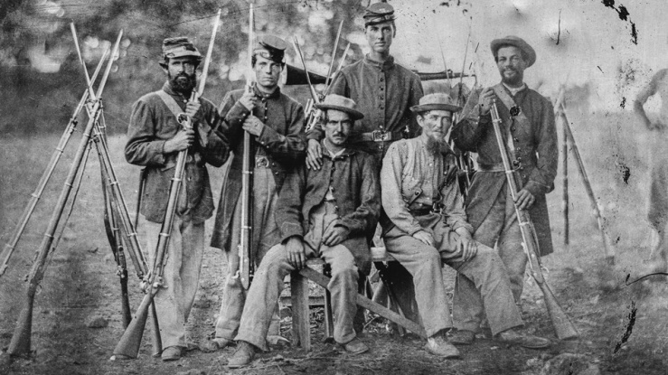

Glorietta Pass resulting in a battle that would be called the Gettysburg of the West, and one in which First Colorado Territorial Governor, William Gilpin, was involved. (More about Glorietta in a future newsletter.)

At about the same time, early1862, an advance force of 120 Confederates left Texas for Arizona Territory (where there was already an active organization of Southern sympathizers), intending to rally them to join in gaining control of California shores. Confederate optimism was squelched when a 2,000-man California patrol, dead set against their mission, overpowered the Confederate troops and local sympathizers near Picacho Peak, 50 miles northwest of Tucson. The Confederates were driven back to Texas. Confrontations occurred in several other Arizona locales as well, but the skirmish at Picacho Peak was the westernmost confrontation in the Civil War.

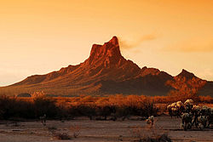

Thwarting the South’s strategy to control the Southwest had consequences beyond the Civil War. As the Union gained strength, conflict in the West turned from preoccupation with secession to a zealous desire to rid the territory of the Indian tribes that stood in the way of westward movement. Settling of the West would have dire outcomes for those who already inhabited it.

